WEEK 1 – FIRST LLM API CALL USING GEMINI
Step-01: Project Folder Creation
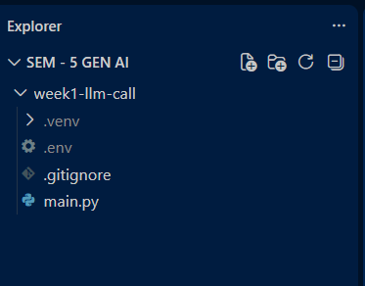
Step-02: Virtual Environment Creation and Activation
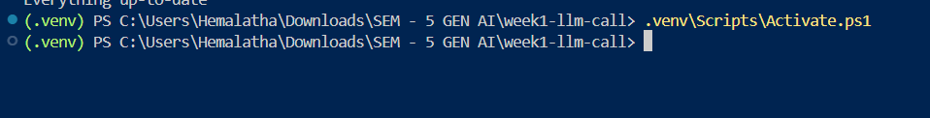
Step-03: Gemini API Key Configuration
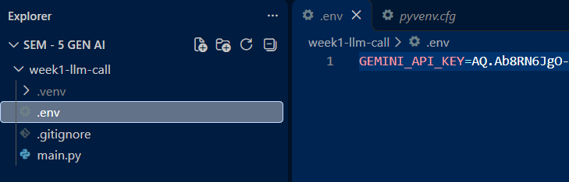
Step-05: Git Ignore Configuration
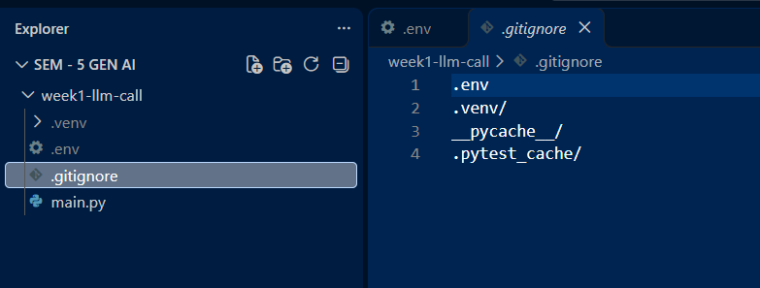
Step-06: Python Program Creation
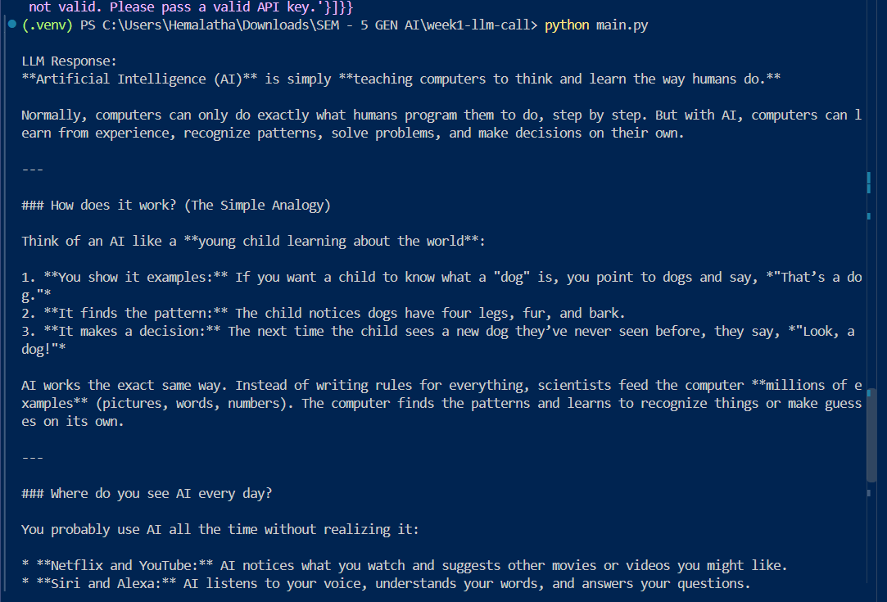
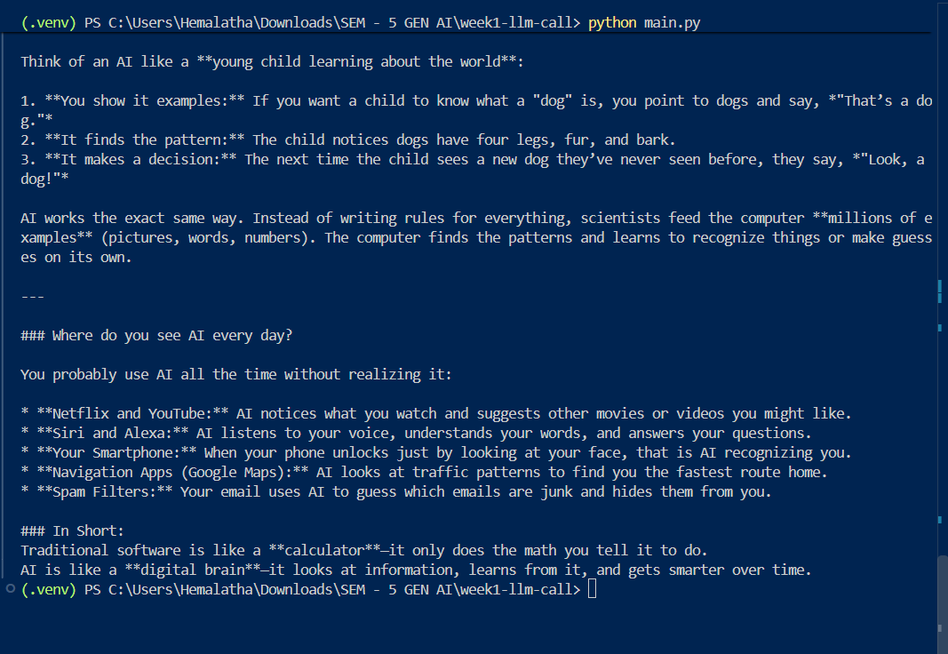
Step-08: Git Initialization and Commit
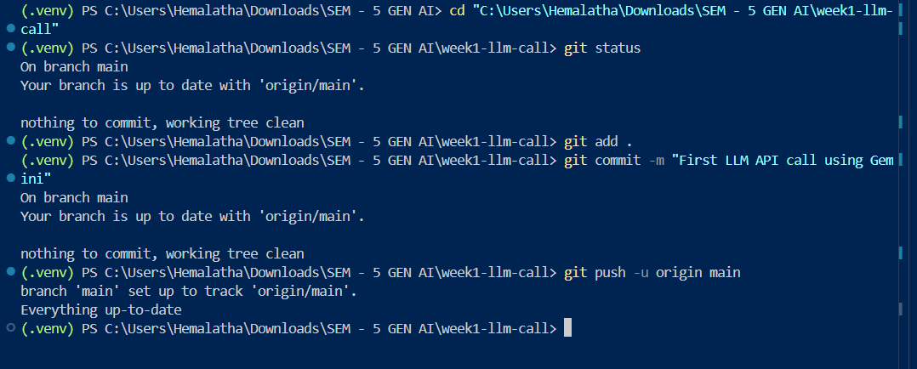
Step-09: Uploading Project to GitHub


